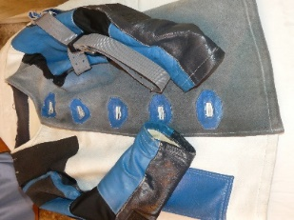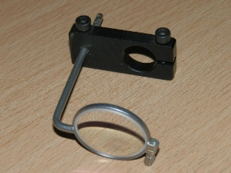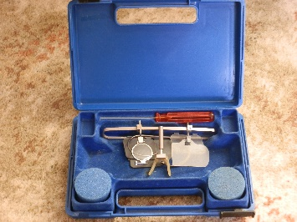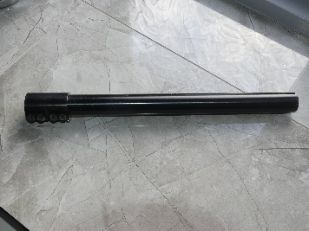

- Jacket – leather Akah 38”/40” ….£20
- Shooting glasses – Champion….£25
- Extension tube – Barry Nesom, & adapter….£15 (Used with Anschutz 1413)
- Monoframe Anschutz lens holder (Edinkillie £59)…£15

(shooting hat or showerproof rifle slip with any of the above)

Glynn Jones 01937 574170 glynnjones57@gmail.com Leeds 17

